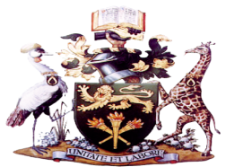
UNSA 2026 INDEPENDENT ELECTORAL COMMISSION

BIO DATA DECLARATION FORM

NAME: _______________________________________________________

REGISTRATION NUMBER: _______________________________

ID/PP NO.: ______________________________________________

NATIONALITY _________________________ GENDER: ______________

COUNTY OF ORIGIN: __________________________________

ETHNICITY: ___________________________________________

FACULTY/CAMPUS: ____________________________________________

YEAR OF STUDY: ______________________________________

COURSE OF STUDY: ____________________________________

MOBILE: ______________________________________________

UNIVERSITY EMAIL: _______________________________________________

I ______________________________________________ declare that the above information is true to the best of my knowledge and ability. I sign this to confirm that the above information is true and further if any information is found to be false; IEC and the University may take appropriate action against me and my team in accordance with the UNSA constitution 2017, Amended 2021 and University of Nairobi regulations.
___________________________ ___________________________
SIGNATURE DATE

NOTE: THE UNIVERSITY OF NAIROBI IS A DULY REGISTERED DATA CONTROLLER AND DATA PROCESSOR UNDER THE DATA PROTECTION ACT NO. 24 OF 2019

